**Forest Fire Prediction**

Ms Sobha Ashwal

Department of Computer Application (GEHU, Dehradun)

**Chaitanya Jeena**

[Chaitanyajeena1@gmail.com](mailto:Chaitanyajeena1@gmail.com)

**[MCA 2022-2024 GEHU Dehradun]**

**Abstract**

Forest Fire Prediction play very important or major role in resource allocation. This is a very major environmental problem that creates very big amount of destruction in world which is also effect the ecosystem, and which is also increase the risk of natural hazards and decreases the so many other resources. The main causes of forest fire like High temperatures and dryness and lightning and volcanic eruptions these all are natural disaster for forest fire but there is some men made causes for forest fire like cigarette and electric spark or any other material. In this article, we focused to prevent the forest from fire. In an article it take, three parameters like current temperature of forest or the second parameter is oxygen level and the last parameter is humidity. In behalf of these three parameter it predict either the forest is safe or in danger. So there is so many algorithms but I use Logistic Regression algorithm which is supervised machine algorithm that use binary values 0 and 1.In this article if output comes 0 that means forest is safe not in danger but if output comes 1 that means forest is in danger there is very high chances of fire in forest. I achieved approximately 96% accuracy in this project, which is decent.

Keywords:-

Forest fire, Machine learning, algorithms

**1-Introduction**

In recent years, the frequency of forest fire have increased due to so many factors like climate change and humans activities etc. As a result, by seen this type of big problem for world we need a good and effective forest fire prediction models with good accuracy to help humans by predict so we are ready to face any problem in forest. So we use Logistic Regression algorithm which is supervised machine algorithm that use binary

Values zero and 1. In the article if output comes zero that means forest is safe not in danger but if output comes one that means forest is in danger there is very high chances of fire in forest. Either in behalf of this models prediction the forest is in danger or not so, we humans are ready to face any big problem in forest like fire in forest. But this model only predict with the help of three parameters which is current temperature , humidity and last one is oxygen level by giving these three parameters correctly to this model then it predict correctly. Therefore, as we know every models or anything has two sides, which is advantages and disadvantages, so this models also has advantages and disadvantages. So first if I talk about the advantages the big advantage of this model is help humans by predict correctly either the forest safe or not. and now if talk about disadvantages so the main disadvantage of this it predict only by seen the current atmosphere, but still there is chances of fire in forest which is by natural like lightning in cloudy weather in forest so there is so many chances that forest is safe or not. Moreover, the other disadvantage of this by humans activities like throwing cigarette in forest or bonfire in a forest so these all are the advantages and disadvantages of this model.

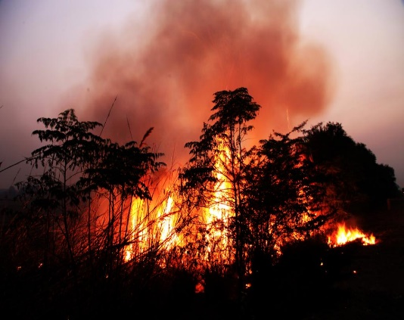

Fig.1

“India reported 345,989 forest fires from November 2020 to June 2021, according to the State of Forests Report, 2021 (SoFR, 2021), released January 13, 2022. This is the highest recorded in the country for this period so far.

At least [258,480 forest fires were reported during the same time in 2018-19](https://pqars.nic.in/annex/255/Au2125.pdf), and were the second-highest so far, according to data presented by Ashwini Kumar Choubey, minister of state in the Union environment ministry, in the Rajya Sabha December 16, 2021.”

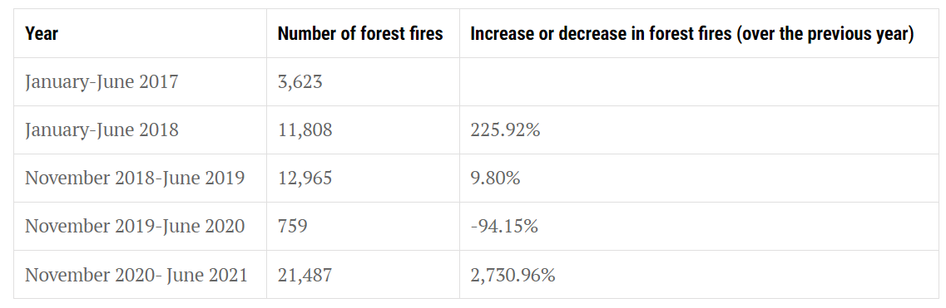

Fig.2

“Forest fires break out in India from November-May every year due to various natural and anthropogenic reasons including accumulation of inflammable materials such as dry leaves, twigs, pine needles, etc.

This is 2.7 times more than the fires reported between November 2019 and June 2020. This includes large, continuous and repeated forest fires.

The country has seen this increase after a decrease in forest fire counts in the last two most recent forest seasons — November 2018-June 2019 and November 2019-June 2020.

[Odisha reported the maximum fires among all states](https://www.downtoearth.org.in/news/environment/odisha-recorded-the-most-forest-fires-in-india-last-season-78129)(51,968), followed by Madhya Pradesh (47,795) and Chhattisgarh (38,106).

[Uttarakhand recorded the sixth-highest fire](https://www.downtoearth.org.in/news/climate-change/climate-crisis-uttarakhand-may-see-forest-fires-round-the-year-74926) counts in the country; incidences were up 28.3 times this forest fire season compared to last.”

**“Uttarakhand recorded 28.3 fold increase in forest fire incidences between Nov 2019-June 2020 and Nov 2020-June 2021”**

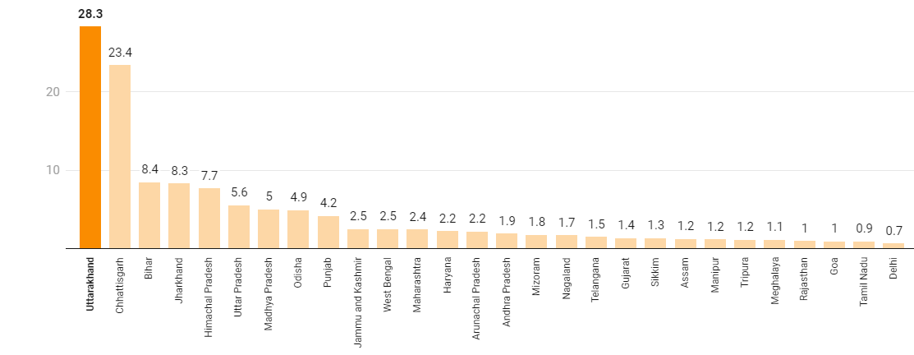

Fig.3

“While forest fires are a recurring and common phenomena, their frequency has been on the rise in the state over many years.

There were 21,487 incidents of fire in Uttarakhand’s forests between November 2020 and June 2021. The figure for the same period in the previous year was 759.”

“This could be seen as another manifestation of climate change. SoFR, 2021 too acknowledged the link between climate change and forest fires, citing the global forest resources assessment 2020.”

“The report has mapped climate change hotspots in Indian forests based on projections for 2030, 2050 and 2080 and alerted that the state will record the maximum increase in temperature and possibly a decrease in rainfall.”

“Chhattisgarh recorded 23.3 times more forest fire counts than last season; Bihar 8.4 times more than last season.

Forests are managed by the state forest departments.

The Union environment ministry supports the efforts of state / Union territory governments in preventing and controlling forest fire by providing financial assistance for various forest fire prevention and management measures under the centrally sponsored forest fire prevention and management scheme.

A total of Rs 125 crore has been released to the states in the last three years (2018-19 to 2020-21) under this scheme, according to the statement in the parliament December 16, 2021. ”[1]

Fig.1, 2, 3: Source (<https://www.downtoearth.org.in/news/forests/forest-survey-report-2021-forest-fire-counts-up-2-7-times-81123>).

[1] (<https://www.downtoearth.org.in/news/forests/forest-survey-report-2021-forest-fire-counts-up-2-7-times-81123>).

**2. CLASSIFICATION OF FIRE PIXEL**

This section covers the detail of the proposed fire pixel classification algorithm. Figure 2 shows the flow chart of the proposed algorithm. Rule based color model approach has been followed due to its simplicity and effectiveness. For that, color space RGB and YCbCr is chosen. For classification of a pixel to be fire we have identified seven rules. If a pixel satisfies these seven rules, we say that pixel belong to fire class.

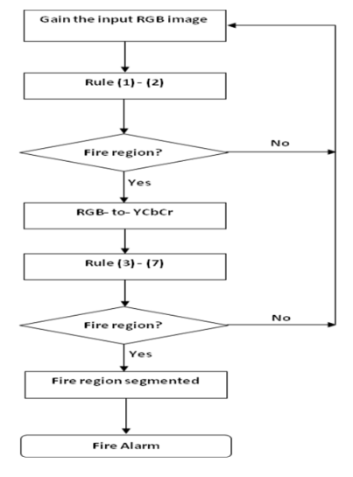

**Fig.2: Flow chart of proposed algorithm for forest fire detection.**

A digital colored image has three planes: Red, Green and Blue (R, G, and B). The combination of RGB color planes gives ability to devices to represent a color in digital environment. Each color plane is quantized into discrete levels. Generally 256 (8 bits per color plane) quantization levels are used for each plane, for instance white is represented by (R, G, B) = (255, 255, 255) and black is represented by (R, G, B) = (0, 0, 0). A color image consists of pixels, where each pixel is represented by spatial location in rectangular grid (x, y), and a color vector (R(x, y), G(x, y), B(x, y)) corresponding to spatial location (x, y). A. Rule I It can be noticed from figure 3 that for the fire regions, R channel has higher intensity values than the G channel, and G channel has higher intensity values than the B channel.

**3. PERFORMANCE EVALUATION**

For performance evaluation we have used classification error matrix. Table III shows the classification error matrix for the developed classifier. For this we have collected two sets of images from internet. One set composed of images that consist of fire. The fire set consist of 200 images, with diversity in fire-color and environmental illuminations. The other doesn’t contain any fire, but contains fire-colored regions such as sun, flowers, reddish objects, etc. The following condition is used for declaring a fire region: if the model achieves to detect at least 10 pixels as fire, then it is assumed that the image has fire region in it. For false alarm rate the same criterion is used with the nonfire image set. Classification error matrix is the relationship between known reference data and the corresponding classified result. In this matrix the diagonal elements represents the correctly classified result and non-diagonal elements gives the number of misclassified result.

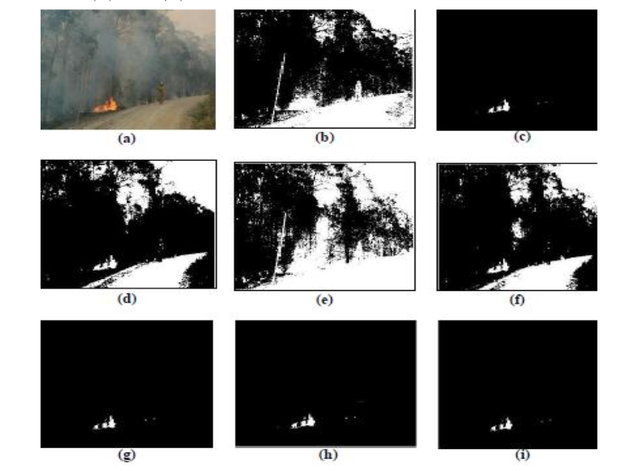

**4. CONCLUSION**

In this research work a rule based color model for forest fire pixel classification is proposed. The proposed color model makes use of RGB color space and YCbCr color space. From this a set of seven rules were defined for the pixels to be classified as fire pixel. The performance of the proposed algorithm is tested on two sets of images; one containing fire and the other with no- fire images. The proposed model achieves 99% flame detection rate and 14% false alarm rate. The arithmetic operations of this model are linear with the image size. Also, the algorithm is cheap in computational complexity. This makes it suitable to use in real time forest fire monitoring system.

**5. FUTURE ENHANCEMENT**

The proposed system can be realized in future and can evaluate the performance of the system in real time forest fire monitoring system. Also, instead of using camera images if we go for videos, then we can calculate the spread of fire with time. Further, the flicker nature of fire can be utilized so as to reduce false alarm rate.

**References**

1. J.R. Gonzalez, M.Palahi, A.Trasobares, T. Pukkala, "A fire probability model for forest stands in Catalonia (north-east Spain)," Annals of Forest Science, pp.169-176, 2006.

2 - E.Kuhrt, J.Knollenberg, V.Mertens. “An Automatic Early Warning System for Forest Fires”. Annals of Burns and Fire Disasters, vol. XIV, pp.151-154, 2001.

3 - L. Yu, N. Wang, X. Meng, “Real-time Forest Fire Detection with Wireless Sensor Networks”, Proceedings of International Conference on Wireless Communication, Networking and Mobile Computing, vol.2, pp.1214-1217,2005.

4 - Z. Li, S. Nadon, J. Cihlar, “Satellite detection of Canadian boreal forest fires: development and application of the algorithm,” International Journal of Remote Sensing, vol. 21, no. 16, pp. 3057- 3069, 2000.

5 - T. J. Lynham, C. W. Dull, and A. Singh, “Requirements for spacebased observations in fire management: a report by the Wildland Fire Hazard Team, Committee on Earth Observation Satellites (CEOS) Disaster Management Support Group (DMSG),” IEEE International Geoscience and Remote Sensing .Symposium, vol. 2, pp. 762-764, June 2002.